Madeline Wray

12/2/2021

UCare Texas: Reproductive Health News for You

Imagine you are in crisis. Yesterday, your pregnancy test came back positive. You panic, not knowing what to do, so you resort to a frantic Google search of near-by women’s health clinics, but you are met with a flurry of results too far away, too expensive, too complicated for you to understand without a substantive knowledge of reproductive healthcare. The next morning, after a night of anxiety-ridden sleep, you drive yourself, alone and scared, to the first Planned Parenthood that had popped up in your search results—about an hour’s drive away. You are finally hopeful, maybe this can all be over soon—until she tells you that if you terminate your pregnancy now, you are breaking the law. One month ago, Texas passed a state law that makes any abortion after six weeks into the pregnancy illegal.

You wonder, how did I not know?

State legislation flies under the radar far too often, especially with controversial topics like reproductive health rights. It’s easy to stay up-to-date with political changes when you are constantly bombarded by the national politics reporters on large news conglomerates like CNN and Fox News, but sometimes the laws that affect you the most are passed by smaller state legislatures that news giants don’t have the capacity or time to cover.

Local news organizations were once the answer to that issue. Their small scale enabled them to focus on smaller-scale politics and community stories, content directly applicable to their audience. Unfortunately, however, local news has started to disappear across the country, being pushed out by those larger news organizations. National news organizations may be able to cover more topics, or launch more research-intensive investigations, but when it comes to the causes that directly affect citizens, the coverage they provide can seem far away.

Independent news organizations, nonprofits, and thinktanks across the country have begun to latch onto the cause of reviving local news in a multitude of different ways, one of those being cause-based local news organizations. There are plenty of cause-based activists running national or international news blogs or social media accounts, but they lack that most important aspect: specificity.

Imagine you are that woman again. Now, imagine that before that day, you had subscribed to a regional newsletter after seeing their site advertised on a women’s rights social media post. You subscribed for the content they provided about women’s rights, but you also began receiving an e-mail newsletter every week with updates on new legislature in your district on reproductive healthcare. You were able to hear about that new law restricting abortion access before it was even passed, and you were immediately linked to resources to help if you encountered the consequences of that law in the future. These resources were applicable just for you: clinics, support groups, living centers, all in your regional area. Names of doctors, numbers to call, all in your regional area. Not only would you have known the restrictions and dangers that you could be facing, you would have been well-equipped with accessible nearby resources you knew you could trust.

This could be the situation with UCare Texas, a new online news organization dedicated to informing and protecting the reproductive health rights of women, femme-identifying, and people with uteruses on a regional basis throughout Texas. The “U” in the UCare name implies that the site is dedicated to uterus-having individuals, which makes sure to acknowledge the diversity of genders and identities that are affected by uterine reproductive health laws; but truly, “UCare” is a way to show that we, and so many others, *do care* about advocating for people with uteruses.

**Audience**

The primary audience for this organization will be those most affected by Texas reproductive healthcare laws: people with uteruses living in Texas. These are the people most in need of up-to-date information and news on reproductive legislation in Texas, so they will be most likely to desire our content. In terms of age, the nature of the cause will naturally make the organization appeal more to a younger audience, which is why our membership system (explained later in the “Membership” section) is structured in a way to appeal to younger audiences. However, the news and resources provided by UCare Texas can be valuable to anyone interested in local politics, activism, or healthcare workers of any age. In addition, because UCare Texas is a cause-based organization, it appeals to larger audiences nationally (and potentially internationally) as information on Texas laws can be valuable for anyone invested in reproductive healthcare policies and activism.

**Location**

As a reproductive health news organization, Texas is the ideal—and most necessary—place to launch our journalistic initiative. Texas is a current hotspot for discussion of reproductive healthcare rights, as the state legislature has been systematically placing more and more restrictions on reproductive health services and rights. In fact, from 2013 to 2021, 23 clinics offering surgical abortions closed as a result of more stringent laws being imposed by the state, making it more and more difficult for people in need to access that type of reproductive healthcare.[1] There has been widespread outrage throughout Texas and the entire nation after the state recently passed a law outlawing abortion after six weeks into a pregnancy, the strictest term limit in the country.[2] Texas is the center of national outrage, so outside interest and focus is strong right now. This controversy will enable UCare Texas to draw in outside investors as potential donors and sponsors, giving our organization Texas an opportunity to become well-established and well-funded early on. Texas is also a very large state, so a regionally-based organization loyal to local journalism values will help both distinguish UCare as a unique organization that brings focus to smaller communities within the state, and one that can better meet the specific needs of regions across the state.

**Structure and Distribution**

The content of UCare Texas will be spread through multiple different formats. The primary form of journalistic content distribution will be a website, with the most important aspect being its regional specificity. By creating a free account and inputting the region they live in, readers will be able to filter everything to their own region. This is the unique aspect of UCare Texas; it is a statewide website that can be shrunk down to meet each community’s specific needs. This way, they are not bombarded with irrelevant articles and resources, and members feel as though they are seen by an organization that genuinely cares about their smaller regions’ unique issues.

The website will be structured in a similar style to most other news sites, such as the New York Times or the Texas Tribune, to ensure the site is easy to navigate. It will be divided into sections based on each different topic: “Our Mission,” “Our Team,” “Health,” “News,” “Spotlight,” and “Resource Center.” The first two sections are intended to both state a clearly defined journalistic mission, and to foster a more personal connection between readers and the organization. Local news organizations are on a small enough scale to foster that kind of personal connection, something that is an integral part of local news; it shows how local news offers different something different than what larger organizations are capable of. The “Our Team” section will focus on showing the faces behind the journalism; there will be a list of each region’s designated reporters, with photos, biographies, contact information and social media accounts. This way, readers feel like they know the journalists that are accountable to them; this will hopefully increase transparency and that same individual connection. “Health” and “News” are the two more serious journalistic sections for the organization, with the first covering medical news such as newly released studies or available treatments, and the second covering traditional news in sections “Breaking,” which covers important breaking news, “Politics,” which covers political and legislative developments in reproductive rights, “Events,” which covers upcoming events related to reproductive rights, and “Opinion.” The “Opinion” section is where any non-factual or investigative reporting will be categorized. All articles in this section include “Opinion:” at the beginning of the title to ensure there is no misinformation or misinterpretation of individual opinions as facts. The opinion articles could be opinion analysis of laws or issues by the employed journalists, op-eds by politicians, or commentary and stories submitted by readers. It is crucial, however, that these articles are not seen as or promoted as fact, or simply unlabeled, in order to make sure there is true transparency and accountability within UCare Texas. The “Spotlight” tab will include short features of femme-presenting and people with uteruses in the local area who have notable achievements or are making a difference in advocacy. This sort of highlights feature develops community and brings an aspect of “happy news” to the organization to encourage readers to return to a site that may be posting primarily tense or controversial stories. Finally, the “Resource Center” section includes lists of clinics, doctors, appointment portals, and support groups.

The second form of distribution will be an e-mail newsletter, targeted specifically for each region. This newsletter will be sent out on Mondays to free members and additionally on Wednesdays and Fridays for donating members (tiered membership explained later). The newsletter will include the headlines and links to recently published articles from the past week, as well as a larger section on upcoming events or opportunities with links to register and get involved. The point of the newsletter will be to provide a notification aspect for the organization; this way, readers who may be distracted from their involvement will be reminded of the site and what it offers, bringing them back to read.

Additionally, we would try to maintain social media accounts. UCare Texas will focus mostly on Twitter and Instagram, as they appear to be the most effective platforms to promote traveling to another site to view content, because the content on these accounts will likely be directed towards the website itself by advertising new published pieces. Social media is a very effective (and often under- or mis-utilized) tool for smaller organizations to develop a loyal base; social media is the easiest possible way to stay up-to-date with an organization—it just takes one click of the follow button, and a condensed newsletter is at a potential reader’s fingertips every day. Social media is also a fairly cheap way to continue engagement on the daily without much effort or skill required, further contributing to readership loyalty in the main audience demographic, young adults, we predict.

Finally, we would run a podcast focusing on the “Spotlight” section. Each episode of the podcast would expand upon the short biographies of the people highlighted in the Spotlight section of the website, picking one region’s Spotlight feature each week. We expect this podcast to be relatively successful, as it would be simple to create (due to the content already being collected for the Spotlight section) and more entertaining to listen to than an exclusively news podcast. People are passionate about reproductive rights and often like to see people from their communities uplifted; this interest combined with the growth in popularity of podcasts could lead to a successful campaign to draw draw more readers, members, and donors.

**Expenses**

Primary expenses will be paying salaries of reporters and editors; salaries for reporters will range from $40-50k with 1/3 salary benefits, and $75-85k for editors with the same 1/3 benefits. Digital managers will be hired on a freelance basis, mostly to design the initial website and social medias. Further on, the day-to-day digital management would preferably be handled by a distribution of editors and reporters, as it is becoming more and more common for employees to be at least somewhat proficient in web design and management. To begin, we would likely hire 2-3 reporters to cover each region’s sections on the website, with a division of approximately 5 regions. Our editors’ primary duties beyond reviewing pieces would be fact-checking, which is a vital aspect of the organization; each article that has been successfully fact-checked will receive a symbol next to the article title to denote that it has been reviewed and checked. These numbers will be subject to fluctuation as we navigate funding and growth.

**Funding Sources:**

**Membership**

UCare Texas will adopt a tiered membership system based on amount paid per month, with different benefits for each level, increasing in quantity and value the more you agree to pay monthly (levels of $5, 10, 25, and 40). This allows all members to be engaged, even if they cannot afford to be paying a large sum every month. There is also the opportunity to be a free supporter, but this type of membership will only enable you to better personalize your site experience by making an account with your information input, so the benefits of a paid membership will likely outweigh the free one, Providing cheaper options of membership is helpful for maintaining the younger demographics of readers; oftentimes, younger students and adults have smaller incomes and will be discouraged from supporting if the only membership available is a very large fee. Offering these lower levels will hopefully stimulate a larger quantity of members, despite many potentially being low-paying members initially. Pop-ups asking readers to become members to enhance their experience and support our journalistic efforts will appear upon first accessing the site, and a “Become a Member” button appears on the top banner.

**Donations and Grants**

In terms of donations, there will be a “Donate” button on the header line and pop-up advertisement in the website, and will be a link to the donation page in each newsletter as well. There will also be an option to select what type of work you would like your donation to go towards, with options like “investigative resources,” “technological upkeep,” or other services and reporting provided by UCare Texas. This feature establishes yet another method of transparency and honesty for the organization and will likely make large donors more comfortable contributing, as they know what their money will be used for. Next, UCare Texas is hopeful to receive grants from larger Texas and national organizations. As a local news cause-based organization, we have the opportunity to apply for grant funding from both local journalism support grants and reproductive health advocacy grants. Some examples of organizations offering grants like these are the American Journalism Project, which supports rebuilding local news, and the Packard Foundation’s Reproductive Health grants. However, we want to be wary of becoming too reliant on grant funding, as it can be unreliable; this is why we would apply to work with the INN Network Philanthropy Center to ensure we keep our other sources of funding robust enough to survive without grants.

Our final source of funding will be event ticket sales. UCare Texas hopes to host events, such as speaker conferences and benefit concerts, about the subjects we will cover; ticket purchases will be advertised primarily in the newsletter, which will provide a calendar of upcoming events in the recipient’s region each week. Event tickets will also provide even more of an incentive to become a higher paying member as we will give those members priority access to purchasing tickets.

**Impact**

For far too long, people with uteruses have been left on their own, fending for themselves in a country that undervalues and neglects the reproductive health rights they deserve. People are afraid to talk about, advocate for, or engage with the topic, but UCare Texas is determined to change that. UCare Texas is dedicated firmly to the goal of keeping people informed of the laws and policies that affect them directly: not only the national laws that receive attention from news conglomerates, but the local laws and restrictions that slip under the radar and sometimes endanger the lives and well-being of people with uteruses everywhere. UCare Texas believes in the power and importance of local news in fostering community and individualized understanding, and in the unique ability of local news to ensure every piece of news is seen and every voice is heard.

**Website Header Design**

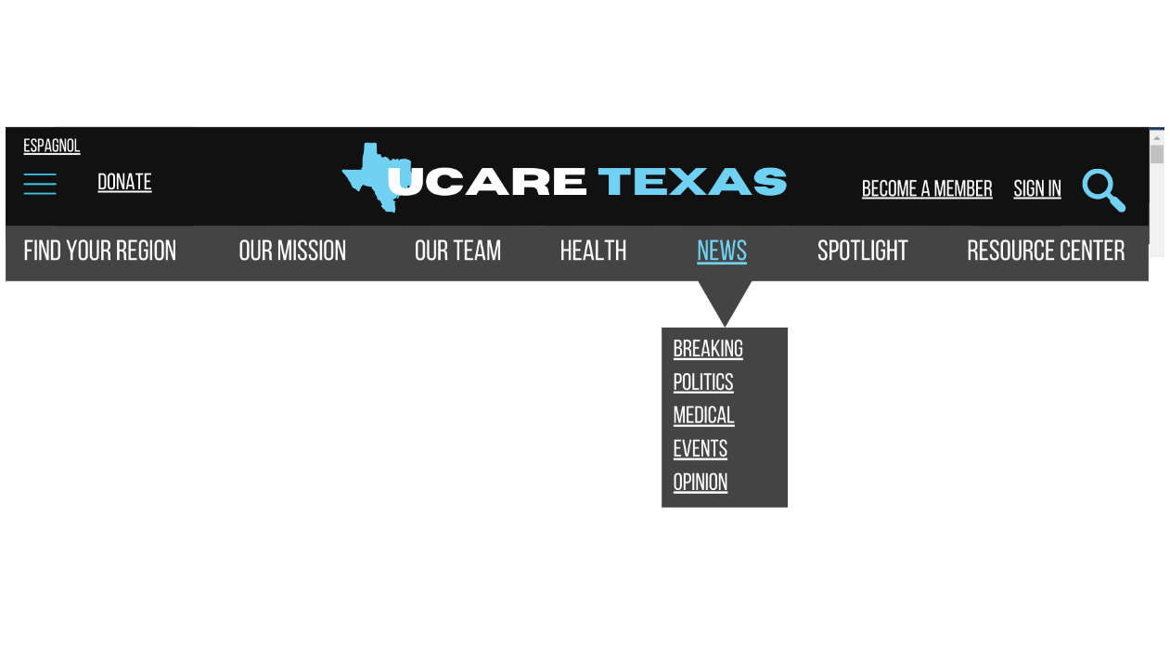

**Newsletter Sample**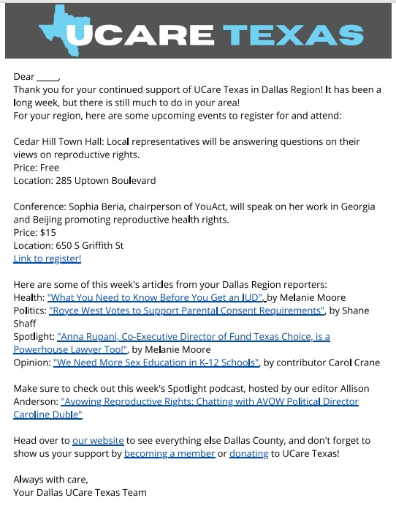

1. Person, and Julia Harte. “Texas Abortion Clinics Struggle to Survive under Restrictive Law.” *Reuters*, Thomson Reuters, 1 Oct. 2021, https://www.reuters.com/world/us/texas-abortion-clinics-struggle-survive-under-restrictive-law-2021-09-30/.
2. Rabin, Roni Caryn. “Answers to Questions about the Texas Abortion Law.” *The New York Times*, The New York Times, 1 Sept. 2021, https://www.nytimes.com/2021/09/01/health/texas-abortion-law-facts.html.